Bell Ringer 6th Grade
Week of 1/21/2019 to 1/25/2019

Monday 1/21/2019- NO SCHOOL MLK DAY
Tuesday 1/22/19
- Remove Topic 3 from your textbook. Keep this in your folders as you will need them to study for your test.
- Turn to page 107 of your TB and complete the “Connect it “ activity.
- What happened to the water in this lake? Why do you think this happened?
- Using your TB pages Define the following:
  - System:

  - Feedback:

Wednesday 1/23/19
- Name a reason why melting glaciers are considered positive feedback.

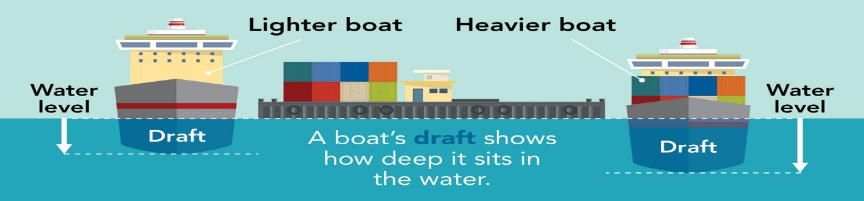
Thursday 1/24/19
Interacting Spheres: Read page __________ of your TB pages.

- Read “ Interacting Spheres “ Compare the model above to what is occurring in Greenland.

Friday 1/25/19

